PART A
(Part A: TO BE REFERRED BY STUDENTS)
Experiment No. 01
A.1 AIM:
Study of Basics of Web Programming.
A.2 Pre requisite:
Basic Knowledge of Internet, Web Browsers, Web Servers.
A.3 Outcome:
After successful completion of this experiment students will be able to:
- Understand structure of web pages.
- Understand content of web pages.
- Features & shortcomings of the website.
- Working of Web Browsers, Web Servers, Protocols & Client Server Architecture.
A.4 Theory:
Website or simply site, is a collection of related web pages, including multimedia content, typically identified with a common domain name, and published on at least one web server. A website may be accessible via a public Internet Protocol (IP) network, such as the Internet, or a private local area network (LAN), by referencing a uniform resource locator (URL) that identifies the site.

Websites have many functions and can be used in various fashions; a website can be a personal website, a commercial website for a company, a government website or a non-profit organization website. Websites are typically dedicated to a particular topic or purpose, ranging from entertainment and social networking to providing news and education. All publicly accessible websites collectively constitute the World Wide Web, while private websites, such as a company's website for its employees, are typically a part of an intranet.

A.4 Tasks to be Performed:
- Explain the following terms :
  - Internet
  - WWW
  - MVC Model
  - Web Server and its types
  - Client
  - Browser and its types
  - Web Pages and its types
  - Client Server Architecture and its types
  - URL
  - Router
  - Gateways
  - DNS
  - JSON
- List atleast 5 features and shortcomings of any site as per your point of view.
- Explain the various parts of a url w.r.t. the url: https://en.wikipedia.org/wiki/HTML
- Explain the protocol used in the above url.
- Open the url given in Task 3 in atleast 3 different browsers and observe and list the differences based on page layout, speed, appearance, etc.
- Explain and Demonstrate the use of following command line commands:
  - ping
  - nslookup
  - ipconfig
  - netstat
  - tracert

PART B
(PART B: TO BE COMPLETED BY STUDENTS)
(Students must submit the soft copy as per following segments within two hours of the practical. The soft copy must be uploaded on the Blackboard or emailed to the concerned lab in charge faculties at the end of the practical in case the there is no Black board access available)
Roll No. : | Name:
Class : | Batch :
Date of Experiment : | Date/Time of Submission :
Grade :

B.1 Findings:
(Paste your learnings here)

B.2 Output

1.
a.
The Internet is a global network of interconnected computers and devices. It allows people to share information and communicate worldwide. The Internet works using standard communication protocols like TCP/IP. It connects millions of private, public, academic, and government networks. Users can access services such as email, websites, and file sharing. The Internet does not belong to any single organization. Data travels across the Internet in the form of packets. Each packet may take a different path to reach its destination. Internet access is provided by Internet Service Providers (ISPs). Devices connect through wired or wireless connections. The Internet supports multimedia such as text, audio, video, and images. It enables online education, shopping, banking, and social networking. Security on the Internet is maintained using encryption and firewalls. The Internet has transformed how people work and learn. It is one of the most important technologies in modern life. The Internet supports cloud computing services. It allows real-time communication like video calls. Social media platforms depend on the Internet. Businesses use it for marketing and sales. Governments use the Internet for public services. The Internet continues to grow rapidly.
b. The World Wide Web is a service that runs on the Internet. It consists of a collection of interlinked web pages. These web pages are accessed using web browsers. The WWW uses the HTTP or HTTPS protocol. Each web page is identified by a unique URL. Web pages are created using languages like HTML, CSS, and JavaScript. The Web allows users to navigate from one page to another using hyperlinks. It supports multimedia content such as images, videos, and animations. The WWW was invented by Tim Berners-Lee. It made the Internet easy to use for common people. Websites can be static or dynamic. Search engines help users find information on the Web. The WWW is widely used for information sharing and communication. It supports web applications like email and social media. The WWW is only a part of the Internet, not the whole Internet. The Web enables online learning platforms. E-commerce websites operate on the WWW. News websites use the Web for global reach. The Web supports interactive applications. It is constantly evolving with new technologies.
c. MVC stands for Model, View, and Controller. It is a software design pattern used in application development. The Model represents the data and business logic. The View represents the user interface of the application. The Controller handles user input and controls the flow of the application. MVC separates application logic from presentation logic. This separation makes applications easier to manage and modify. Changes in the View do not affect the Model directly. The Controller acts as an intermediary between Model and View. MVC improves code reusability and organization. It is commonly used in web frameworks. MVC helps multiple developers work on the same project. It makes debugging and testing easier. MVC supports scalability of applications. It is widely used in modern web development. Popular frameworks like Spring use MVC. It reduces code duplication. It allows parallel development. MVC improves application maintainability. It helps in clean code structure.
d.
A web server is a system that stores and delivers web pages to clients. It responds to requests made by web browsers. Web servers use HTTP or HTTPS protocols. When a user enters a URL, the server sends the requested page. Web servers can be hardware or software based. They store website files like HTML, images, and scripts. Apache is a popular open-source web server. Nginx is another fast and lightweight web server. Microsoft IIS is used mainly on Windows systems. Web servers handle multiple client requests simultaneously. They ensure fast and secure data transfer. Web servers can host multiple websites. They also support server-side scripting. Load balancing can be used with web servers. Web servers are essential for hosting websites on the Internet. They provide access control mechanisms. Web servers support SSL certificates. They log client requests. They help manage website traffic. Web servers ensure high availability
e.
A client is a device or software that requests services from a server. It can be a computer, mobile phone, or tablet. Clients communicate with servers over a network. A web browser is an example of a client application. Clients send requests using protocols like HTTP. They receive responses such as web pages or data. Clients usually have a user interface. They depend on servers for data storage and processing. Clients can be thin or thick clients. Thin clients rely heavily on servers. Thick clients perform more processing locally. Clients initiate communication in client-server architecture. They do not share resources directly with other clients. Clients are designed for user interaction. They play an important role in network communication. Clients can run on different operating systems. They support multitasking. Clients improve user productivity. They access remote services. Clients are essential in distributed systems.

f. A browser is software used to access web pages. It interprets and displays HTML content. Browsers allow users to navigate the World Wide Web. They support multimedia content like images and videos. Browsers use HTTP or HTTPS protocols. Examples include Google Chrome and Mozilla Firefox. Microsoft Edge is a modern web browser. Safari is commonly used on Apple devices. Browsers can be text-based or graphical. Graphical browsers display images and graphics. Text-based browsers display only text. Browsers store cookies and cache data. They provide features like bookmarks and history. Browsers support extensions and plugins. They help users interact with web applications. Browsers provide security features. They warn users about unsafe sites. Browsers support private browsing mode. They update automatically. Browsers improve web accessibility.
g. A web page is a document displayed in a web browser. It is usually written in HTML. Web pages can contain text, images, and links. They are identified by URLs. A static web page shows fixed content. Static pages do not change automatically. A dynamic web page shows changing content. Dynamic pages use server-side scripts. Examples include login pages and dashboards. Web pages can be part of a website. They are stored on web servers. Web pages can include multimedia elements. They support user interaction through forms. Web pages can be responsive to different devices. They are the basic building blocks of the Web. Web pages can include scripts. They support user input validation. Web pages can be interactive. They improve user experience. Web pages follow web standards.
h. Client-server architecture is a network model. It divides tasks between clients and servers. Clients request services from servers. Servers process requests and send responses. This architecture improves data management. It allows centralized control of resources. Two-tier architecture has client and server only. Three-tier architecture includes presentation, logic, and database layers. N-tier architecture has multiple layers. It improves scalability and security. Client-server architecture supports multiple users. It is widely used in web applications. Servers handle data storage and processing. Clients handle user interaction. This model is reliable and efficient. It supports distributed computing. It improves system performance. It allows easy maintenance. It ensures data consistency. It supports enterprise applications.
i. URL stands for Uniform Resource Locator. It is the address of a resource on the Internet. A URL specifies the location of a web page. It also defines the protocol used. A URL consists of protocol, domain, and path. Example protocols are HTTP and HTTPS. The domain name identifies the server. The path shows the location of the file. URLs help browsers find resources. They can link to web pages, images, or files. URLs must be unique for each resource. They are used in hyperlinks. URLs can include query parameters. They support secure communication using HTTPS. URLs are essential for web navigation. URLs can be absolute or relative. They help in resource sharing. URLs support bookmarks. They allow deep linking. URLs are human-readable.
j. A router is a networking device. It connects multiple networks together. Routers direct data packets between networks. They determine the best path for data. Routers use IP addresses for routing. They are commonly used in homes and offices. Routers connect local networks to the Internet. They support wired and wireless connections. Routers improve network performance. They reduce network congestion. Routers provide security features like firewalls. They can manage multiple devices. Routers operate at the network layer. They enable data sharing across networks. Routers are essential for Internet connectivity. Routers support NAT technology. They manage bandwidth usage. Routers improve network reliability. They allow remote access. Routers support VPN connections.
k.
A gateway is a networking device or software. It connects different networks using different protocols. Gateways act as entry and exit points. They translate data between networks. Gateways are more complex than routers. They operate at multiple OSI layers. Gateways allow communication between dissimilar systems. They are used in enterprise networks. Email gateways manage email traffic. Internet gateways connect local networks to the Internet. Gateways improve network interoperability. They enhance security and control. Gateways can filter data. They are used in cloud computing. Gateways are important in large networks. They manage protocol conversion. They support secure communication. Gateways control network access. They monitor data flow. Gateways improve network efficiency.
L
DNS stands for Domain Name System. It converts domain names into IP addresses. DNS makes the Internet user-friendly. Humans remember names better than numbers. DNS works like a phone directory. When a URL is entered, DNS is queried. DNS servers return the correct IP address. This allows browsers to connect to servers. DNS uses a hierarchical structure. It includes root, TLD, and domain servers. DNS improves network efficiency. It supports load balancing. DNS also enhances security. It is essential for Internet browsing. Without DNS, the Web would be difficult to use. DNS reduces IP lookup time. It supports domain management. DNS caching improves speed. It supports email routing. DNS ensures reliable connections
M
JSON stands for JavaScript Object Notation. It is a lightweight data interchange format. JSON is easy to read and write. It is easy for machines to parse. JSON uses key-value pairs. Data is stored in objects and arrays. JSON is language independent. It is widely used in web applications. JSON is used for data exchange between client and server. It is commonly used in APIs. JSON supports strings, numbers, and booleans. It is more compact than XML. JSON improves application performance. It is used in RESTful services. JSON is popular in modern web development. JSON supports nested data. It is easy to debug. JSON reduces data size. It is human-readable. JSON supports real-time data exchange.
2. url: https://chatgpt.com/
Features :
- Quick Responses
- Easy to use
- Available anytime
- Helpful for learning
- Support var topics
Shortcomings :
- Needs internet connection
- Limited real-time information
- Limited access
- In Accurate answers
- Hallucination

3
Parts:
Protocol : https://
- It shows how data is transferred between the browser and the website.
- https stands for HyperText Transfer Protocol Secure, which means the connection is encrypted and safe.
Domain Name: chatgpt.com
- This is the main address of the website.
- It identifies the server where the website is hosted.
Top-Level Domain (TLD): .com
- This is the last part of the domain name.
- .com is commonly used for commercial or general-purpose websites.
Path: /
- The path shows the specific page or location on the server.
- Here, / represents the homepage of the website.
4.
HTTP (HyperText Transfer Protocol) is the basic protocol used for transferring data over the internet. It allows a web browser to communicate with a web server to request and receive web pages. Unlike HTTPS, HTTP does not encrypt data, which means the information sent and received is not secure. It is widely used for websites that do not handle sensitive information. HTTP works on a request-response model, where the browser sends a request and the server responds with the requested content. Although still in use, HTTP is gradually being replaced by HTTPS for better security.
5.
When the website was opened in different browsers, a few differences were noticed liike layout remains mostly consistent, but fonts, spacing, and element alignment may appear slightly different. Page loading speed is usually faster on Chrome and Edge, while Firefox may take a bit longer. The appearance, such as colors and font styles, can vary because each browser renders content differently. Overall, the functionality stays the same, but the user experience can change depending on the browser used.
6
a.
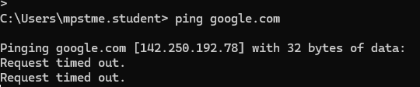
b.
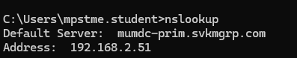
c.
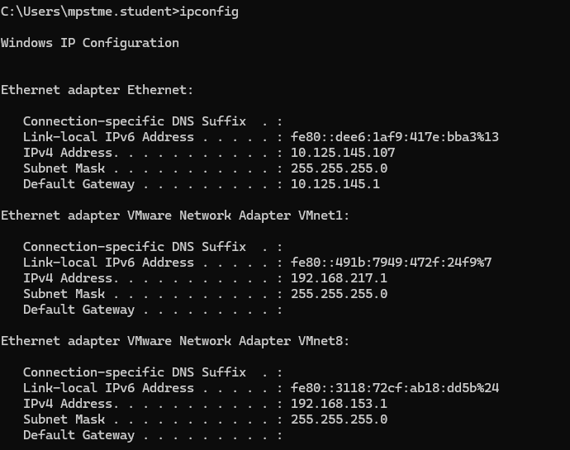
d.
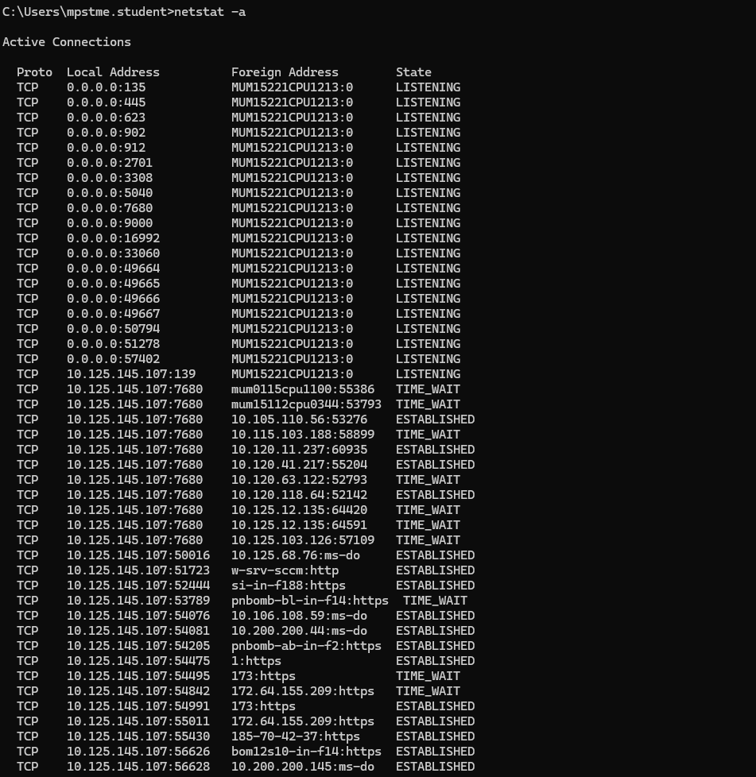
e.
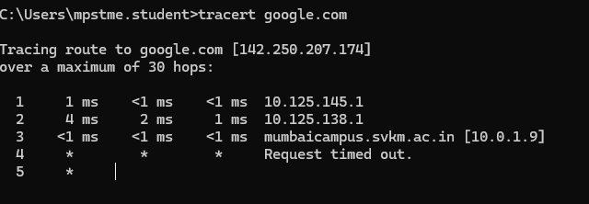

B.3 Conclusion:
(Students must write the conclusion as per the attainment of individual outcome listed above)
I understood the internet, web browsers, and web servers. I learned how the internet enables communication between devices worldwide and how web browsers are used to access and display web content.

B.3 Observations and Learning:
(Students must write their observations and learnings as per the attainment of individual outcome listed above)

I understood the structure and content of web pages, including how information is organized and presented. I also learned about the features and shortcomings of the given website, Wikipedia. Additionally, I gained an understanding of how web browsers, web servers, protocols, and client–server architecture work together to enable web communication.

B.4 Question of Curiosity
(To be answered by student based on the practical performed and learning/observations)
- Differentiate between HTTP and HTTPS. Which is more preferred and why?

HTTP (Hypertext Transfer Protocol) and HTTPS (Hypertext Transfer Protocol Secure) are both protocols used for transferring data between a web server and a browser, but the key difference is security. HTTP sends data in plain text, which can be intercepted by attackers, while HTTPS encrypts the data using SSL/TLS, making it secure from eavesdropping or tampering. Because of this added security, HTTPS is preferred over HTTP, especially for websites that handle sensitive information like passwords, credit card details, or personal data.

- Why is WWW needed even if there is internet?
WWW, which stands for World Wide Web, is needed even though the internet exists because the internet is just the global network of connected computers, while the WWW is a system of accessing and sharing information over this network through web pages and browsers. Essentially, the internet is the infrastructure, and the WWW is one way to use that infrastructure to view and interact with content online.
- What happens if two users request same page at a same time from the same server?
When two users request the same page at the same time from the same server, the server handles both requests simultaneously using processes or threads. Modern web servers are designed to manage multiple requests efficiently, so each user gets a copy of the page without interfering with the other. The server may use caching to speed up responses if the page content hasn’t changed.
- Why is HTML a markup language and not a programming language?
HTML is called a markup language and not a programming language because it is used to structure and present content on web pages rather than perform logical operations or calculations. HTML defines elements like headings, paragraphs, images, and links, but it cannot make decisions, perform loops, or handle data like programming languages such as JavaScript, Python, or C++.

